Configuring Clients for OpenLDAP

Follow these steps in order for you to have them authenticate to your LDAP server. You will do these on your other systems. NOT on the ldap server. (mail, workstation, etc.).
- Install the necessary packages.
(Note: it is ldapd, not ldap)
  - sudo apt install libnss-ldapd libpam-ldapd
  - Set the URI to ldap://ldap.studentXX.230.com.
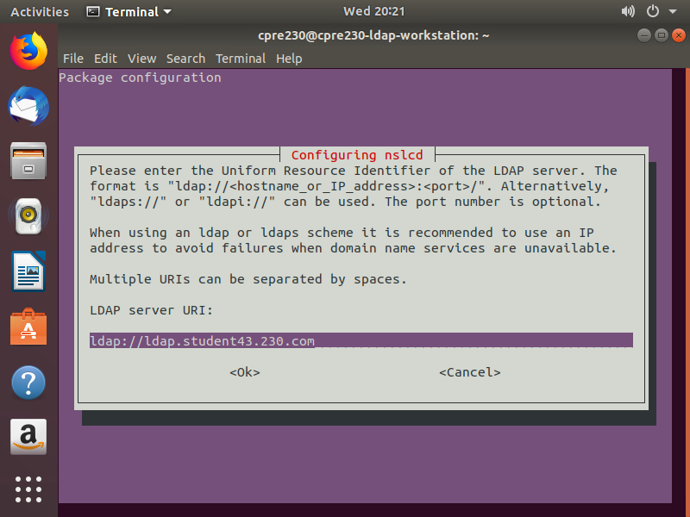
  - Set the search base to dc=studentXX,dc=230,dc=com.
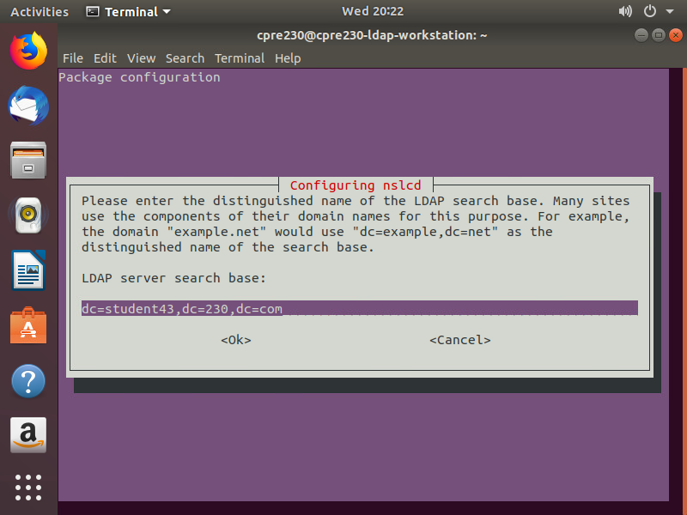
  - When prompted for services, select (by pressing the 'space' key):
- Passwd
- Group
- Shadow
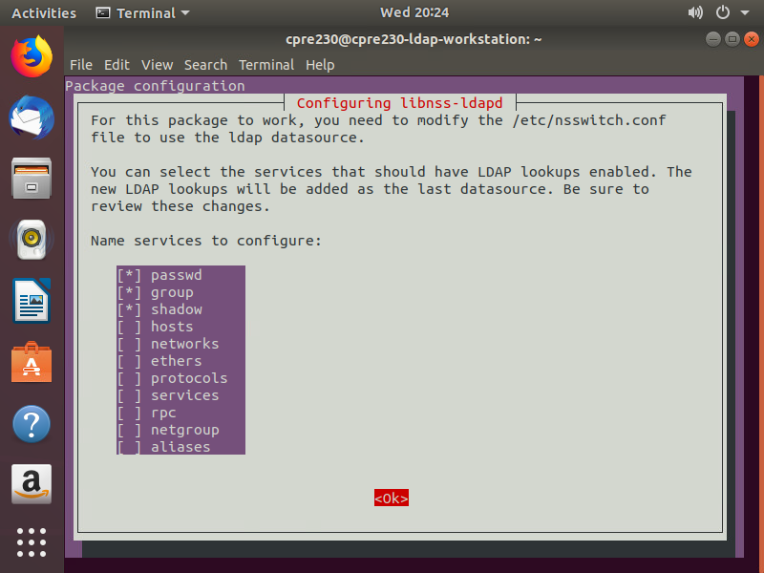
- Configure PAM for authentication against LDAP.
  - Edit /etc/pam.d/common-session (remember to use sudo).
    - Add the following line to the bottom of the file.
session optional pam_mkhomedir.so
    - This will create a user directory if needed when logging in.
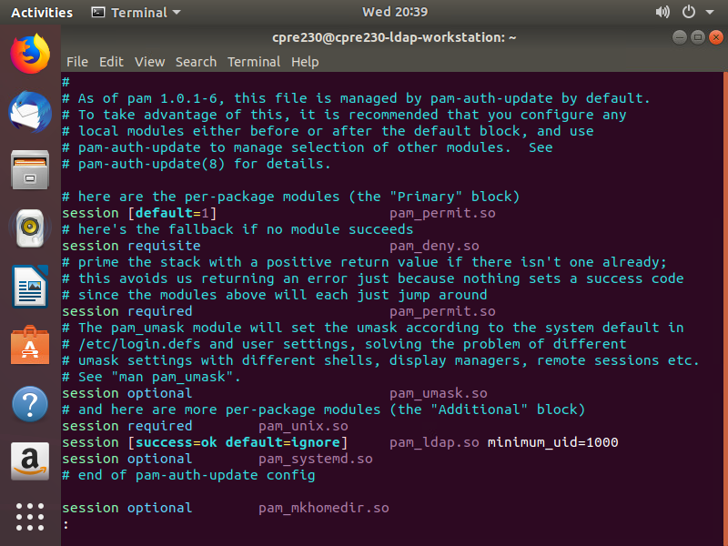
- Reboot to apply the changes.
- Note: if you make a mistake in the initial configuration, run the following command to redo it: sudo dpkg-reconfigure libnss-ldapd
Or edit the settings manually in the following file: /etc/nslcd.conf

